TRAFFIC ESTIMATION AND NUMBER PLATE RECOGNITION USING IMAGE PROCESSING

Major project submitted in partial fulfillment of the requirement for award of the degree

Dasari Aditya
Nirdesh Konireddy
Karnati Rahul



Department of Electronics and Communication Engineering

CHAITANYA BHARATHI INSTITUTE OF TECHNOLOGY

Chaitanya Bharathi P.O., Gandipet, Hyderabad – 500 075
2018

CHAITANYA BHARATHI INSTITUTE OF TECHNOLOGY

Chaitanya Bharathi P.O., Gandipet, Hyderabad-500 075


Department of Electronics and Communication Engineering

CERTIFICATE

This is to certify that the Major project work entitled “Traffic Estimation and Number Plate Recognition using Image Processing” is a bonafide work carried out by

Dasari Aditya (160114735153)
Nirdesh Konireddy (160114735164)
Karnati Rahul (160114735167)

in partial fulfillment of the requirements for the degree of BACHELOR OF ENGINEERING in ELECTRONICS & COMMUNICATION ENGINEERING by the Osmania University, Hyderabad during the academic year 2017-18.

The results embodied in this report have not been submitted to any other University or Institution for the award of any degree.

K. Sudershan Reddy, Assoc. Professor Dr. N. V. Koteshwara Rao
Faculty Guide Professor & Head of Dept.

DECLARATION

We are highly indebted to our Faculty Guide A. Sudershan Reddy, Associate Professor, Electronics and Communication Engineering Department, who has given us all the necessary technical guidance in carrying out this Project.

We wish to express my sincere thanks to Dr. N. V. Koteshwara Rao, Head of the Department of Electronics and Communication Engineering, C.B.I.T., for permitting us to pursue our Project in DIP and encouraging me throughout the Project.

Finally, we thank all the people who have directly or indirectly helped us through the course of Project.

Dasari Aditya
Nirdesh Konireddy
Karnati Rahul

ABSTRACT

Edge detection is an important tool in Digital Image Processing. Edge Detection is process of identifying edges in an image which can be used as a fundamental asset in image analysis. Edge Detection reduces unnecessary information in the image while preserving the structure of image. Various Edge Detectors have been proposed in literature. Among these detectors, Canny Edge Detector is prominent because it’s the most powerful edge detector, simple in implementation with reliable detection. In the Canny Edge Detector technique, initially the image is filtered using Gaussian Filter then enhanced by using gradient. Later thresholding is done using 2X2 neighborhood and finally edges are located using localization technique using Hysteresis.

The Canny Edge Detection technique can be improved by enhancing in 8th neighborhood of a pixel and using adaptive thresholding. In this project an algorithm is developed for improving the Canny Edge Detection technique. The results due to this algorithm are verified with the help of outputs in the form of images. The code is written in MATLAB to carry out these tasks. This improved algorithm finds its applications in surgeries, biometric authentication, machine vision, analyzing anatomical structure.

Contents

CERTIFICATE FROM ECE DEPARTMENT 2
DECLARATION 3
ABSTRACT 4
LIST OF FIGURES 7
LIST OF TABLES 9

Chapter 1 : INTRODUCTION
  - Introduction 10
  - Aim & Objectives 10
  - Literature survey 11
  - Motivation 12
  - Methodology 13
  - Organization of work 16

Chapter 2 : EDGE DETECTION
2.1 Introduction 17
2.2 Gradient 18
2.3 Steps in edge detection 21
2.4 Types of edge detection 22
2.5 Canny edge detector 23
2.6 Conclusion 24
CHAPTER 3: PROBLEMS IN CANNY METHOD
3.1 Working environment 25
3.2 Problems faced in current method 27
3.3 Conclusion 33
CHAPTER 4 : IMPROVED CANNY
4.1 Algorithm for Improved Canny Edge Detection 34
4.2 Flowchart for Improved Canny Edge Detection 37
4.3 Improved Canny Edge Detection code 40
4.4 Conclusion 52
CHAPTER 5 : RESULTS & DISCUSSIONS
5.1 Comparisons 53
5.2 Output comparisons 55
5.3 PSNR and MSE comparisons 66
5.4 Future scope 68
5.5 Conclusion 68

List of Figures

  - Canny detection flowchart 14
  - Improved Canny detection flowchart 15
2.1 Coin recognition 18
2.2 2-D Gaussian equation 19
2.3 gaussian 5*5 matrix 19
2.4 Gaussian kernel operation 20
2.5 Gaussian kernel matrix for sigma = 1.5 21
2.6 Gaussian kernel matrix for sigma = 2.0 21
3.1 Lena original image 28
3.2 Lena output by edge() 29
3.3 Butterfly original image 30
3.4 Butterfly output by edge() 31
3.5 CBIT LOGO original image 32
3.6 CBIT LOGO output using edge() 32
4.1 Flowchart for Gaussian filter and gradient Computation 37
4.2 Flowchart for Non maxima suppression 38
4.3 Flowchart for Hysteresis 39
5.1 Lena original image 55
5.2 Lena output image by edge() 56
5.3 Lena output image using improved canny 56
5.4 CBIT LOGO original image 57
5.5 CBIT LOGO output image by inbuilt function 57
5.6 CBIT LOGO output image by improved canny 58
5.7 Butterfly original image 59
5.8 Butterfly output image by inbuilt function 59
5.9 Butterfly output image by improved canny 60
5.10 Hand original image 61
5.11 Hand output by inbuilt function 62
5.12 Hand output by improved canny 63
5.13 Profiler for inbuilt function 64
5.14 Profiler for improved canny function 65

List of Tables

5.1 Comparison of steps involved in design process 53
5.2 Parameter comparisons 54
5.3 Time comparison 66
5.4 Comparison of PSNR values 67
5.5 Comparison of MSE values 68

CHAPTER 1

INTRODUCTION
1.1 Introduction :
Edge detection includes a variety of mathematical methods that aim at identifying points in a digital image at which the image brightness changes sharply or has discontinuities. The points at which image brightness changes sharply are typically organized into a set of curved line segments termed edges. The same problem of finding discontinuities in one-dimensional signals is known as step detection and the problem of finding signal discontinuities over time is known as change detection. Edge detection is a fundamental tool in image processing, machine vision and computer vision, particularly in the areas of feature detection and feature extraction.
1.2 Aim & Objectives :
To design a better edge detection method to overcome the problems faced by the existing inbuilt matlab function EDGE().
The following are the objectives to be met in order to achieve the aim :
- Detection of edge with low error rate, which means that the detection should accurately catch as many edges shown in the image as possible
- The edge point detected from the operator should accurately localize on the center of the edge.
- A given edge in the image should only be marked once, and where possible, image noise should not create false edges.
- To include adaptive thresholding such that true weak edges should not be lost.

Conventional canny detector operates in the neighborhood of 2*2 which is more sensitive to noise and weak edge will be lost. In the improved model we propose to extend the gradient magnitude to 8thneighborhood which effectively suppress noise and helps in locating the proper edge

1.3 Literature survey :
To fulfill the objectives of this project, concepts related to image processing and edge detection are necessary. Standard books(Digital Image processing by S.Jayaraman, S.Esakkirajan, T.Veerakumar) are referred to get idea about Image Processing. The concept of edge detection is studied from several papers (Ramakant Nevatia et.al 1977, Yang and Tsai et.al 1996, Trahanias and Venetsanapoulos et.al 1996,Y. Zheng et. Al 2010, G. Yang et.al 2011). Several technical papers are referred for knowledge in edge detection techniques like Filtering, Enhancement, Non-maximum suppression, Thresholding, Adaptive thresholding, Localization of Edges by Hysteresis.

1.4 Motivation :
The purpose of detecting sharp changes in image brightness is to capture important events and changes in properties of the world. It can be shown that under rather general assumptions for an image formation model, discontinuities in image brightness are likely to correspond to:

- discontinuities in depth,
- discontinuities in surface orientation,
- changes in material properties and
- variations in scene illumination.
In the ideal case, the result of applying an edge detector to an image may lead to a set of connected curves that indicate the boundaries of objects, the boundaries of surface markings as well as curves that correspond to discontinuities in surface orientation. Thus, applying an edge detection algorithm to an image may significantly reduce the amount of data to be processed and may therefore filter out information that may be regarded as less relevant, while preserving the important structural properties of an image. If the edge detection step is successful, the subsequent task of interpreting the information contents in the original image may therefore be substantially simplified. However, it is not always possible to obtain such ideal edges from real life images of moderate complexity.
Edges extracted from non-trivial images are often hampered by fragmentation, meaning that the edge curves are not connected, missing edge segments as well as false edges not corresponding to interesting phenomena in the image – thus complicating the subsequent task of interpreting the image data.
Edge detection is one of the fundamental steps in image processing, image analysis, image pattern recognition, and computer vision techniques.

1.5 Methodology :
1.5.1 Methodology for conventional Canny detection:
The methodology of canny edge detection algorithm can be broken down to 5 different steps:
- Apply Gaussian filter to smooth the image inorder to remove the noise
- Find the intensity gradient of the image
- Apply non-maxima suppression to get ridof spurious response to edge detection
- Apply double threshold to determine potential edges
- Track edges by hysteresis: Finalize the detection of edges by suppressing all the other edges that are weak and not connected to strong edges

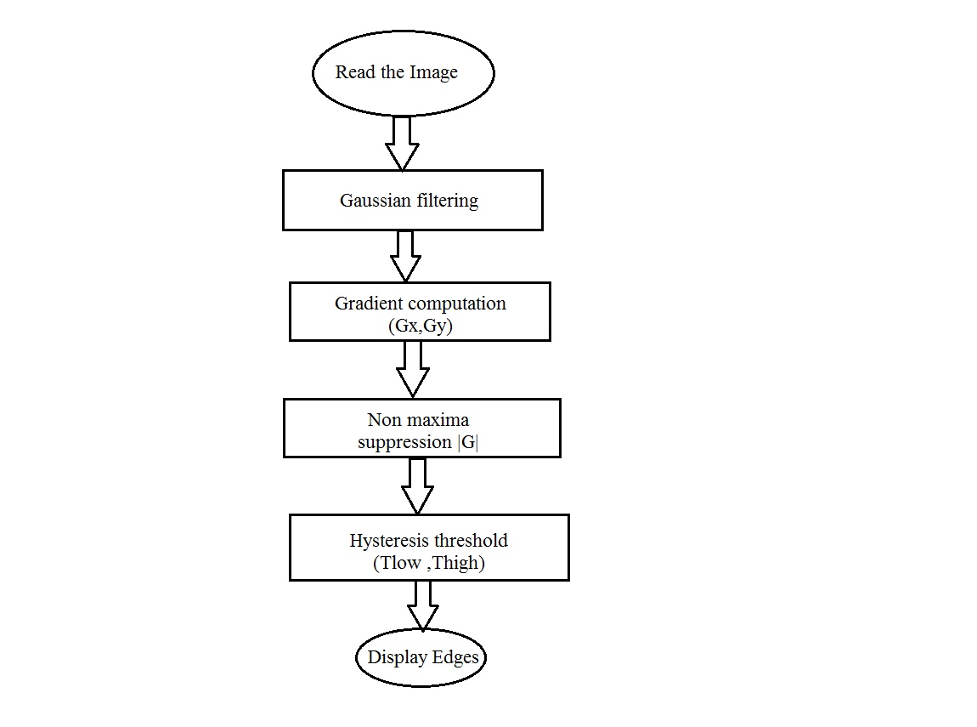
  - Canny detection flowchart

1.5.2 Methodology for improved canny detection:
The methodology for improved canny detection algorithm can be broken down into 5 different steps:
- Apply Gaussian filter to smooth the image in order to remove the noise
- Find the intensity gradient of the image
- Apply non-maximum suppression on 8th neighborhood to get rid of spurious response to edge detection
- Apply Adaptive threshold to determine potential edges
- Track edge by hysteresis: Finalize the detection of edges by suppressing all the other edges that are weak and not connected to strong edges.

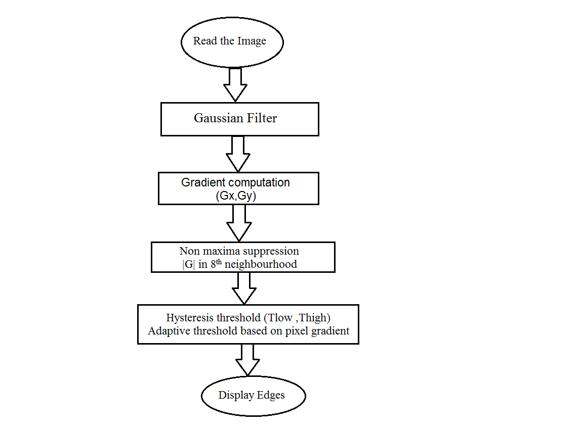
  - Improved Canny detection flowchart

1.6 Organisation of the work:
Chapter 1: Deals with introduction of the project. We begin with Introduction of edge detection and discussed about general literature survey and motivation of our project, and then we have flowcharts for both Conventional canny edge detection and proposed Improved canny edge detection.

Chapter 2: In Chapter 2, we discuss the methods of edge detection and syntax
using edge function.

Chapter 3: In chapter 3 we will see design considerations of canny method in edge
function and the problems faced due to this.

Chapter 4: This chapter deals with ways to overcome the problems faced in chapter 3 by improving the design scheme.

Chapter 5: In this chapter we will see how our proposed methods stands against old
methods by comparing outputs , Profiling time , PSNR , MSE values.

CHAPTER 2
IMAGE PROCESSING

Image processing is a method to convert an image into digital form and perform some operations on it, in order to get an enhanced image or to extract some useful information from it. It is a type of signal dispensation in which input is image, like video frame or photograph and output may be image or characteristics associated with that image. Usually Image Processing system includes treating images as two dimensional signals while applying already set signal processing methods to them.
It is among rapidly growing technologies today, with its applications in various aspects of a business. Image Processing forms core research area within engineering and computer science disciplines too.

Image processing basically includes the following three steps.
Importing the image with optical scanner or by digital photography.
Analyzing and manipulating the image which includes data compression and image enhancement and spotting patterns that are not to human eyes like satellite photographs.
Output is the last stage in which result can be altered image or report that is based on image analysis.

Purpose of Image processing
The purpose of image processing is divided into 5 groups. They are:
1. Visualization - Observe the objects that are not visible.
2. Image sharpening and restoration - To create a better image.
3. Image retrieval - Seek for the image of interest.
4. Measurement of pattern – Measures various objects in an image.
5. Image Recognition – Distinguish the objects in an image.

Types
The two types of methods used for Image Processing are Analog and Digital Image Processing.

Analog Processing: Analog image processing is done on analog signals. It includes processing on two dimensional analog signals. In this type of processing, the images are manipulated by electrical means by varying the electrical signal. The common example include is the television image.Analog or visual techniques of image processing can be used for the hard copies like printouts and photographs. Image analysts use various fundamentals of interpretation while using these visual techniques. The image processing is not just confined to area that has to be studied but on knowledge of analyst. Association is another important tool in image processing through visual techniques. So analysts apply a combination of personal knowledge and collateral data to image processing.

Digital Processing: Digital Processing techniques help in manipulation of the digital images by using computers. As raw data from imaging sensors from satellite platform contains deficiencies. To get over such flaws and to get originality of information, it has to undergo various phases of processing. The three general phases that all types of data have to undergo while using digital technique are Pre- processing, enhancement and display, information extraction.

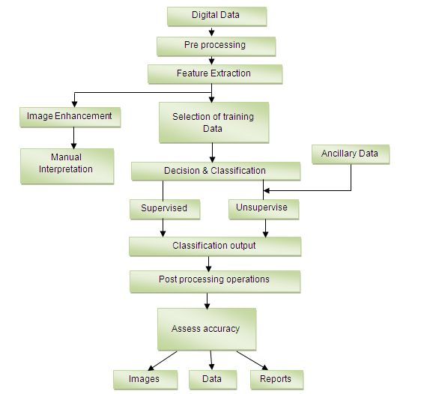

CHAPTER 3
TRAFFIC DENSITY ESTIMATION

3.1 Raspberry Pi:
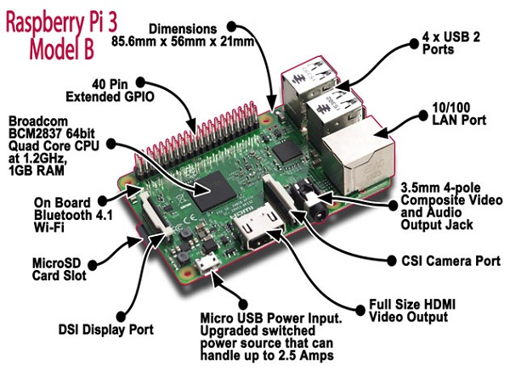
The Raspberry Pi is a series of credit card–sized single-board computers developed in the UK by the Raspberry Pi Foundation with the intention of promoting the teaching of basic computer science in schools.The system is developed through ARM microprocessor ARM is a registered trademark of ARM Limited. Linux now provides support for the ARM-11 family processors; it gives consumer device manufacturers, commercial-quality Linux implementation along with tools to reduce time-to-market and development costs. Raspberry Pi is a credit card sized computer development platform based on a BCM2837 system on chip, sporting an ARM11 processor, developed in the UK by Raspberry Pi Foundation. Raspberry Pi model functions as a regular desktop computer when it is connected to the keyboard or monitor. Raspberry Pi is very cheap and most reliable to make a Raspberry Pi supercomputer. The Raspberry Pi uses Linux kernel-based. The Foundation provides Debian and Arch Linux ARM distributions for download.Tools are available for Python as the main programming language, with support for BBC BASIC(via the RISC OS image or the Brandy Basic clone for Linux), C, C++, Java,Perl and Ruby.
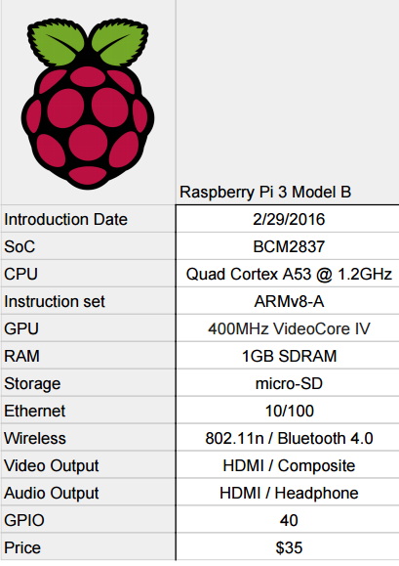

Raspberry Pi consists of General Purpose Input Output (GPIO) pins which are used as a physical interface between the Pi and the outside world. At the simplest level, you can think of them as switches that you can turn on or off (input) or that the Pi can turn on or off (output).  Seventeen of the 26 pins are GPIO pins, the others are power or ground pins. When programming the GPIO pins there are two different ways to refer to them: GPIO numbering and physical numbering.
GPIO NUMBERING: These are the GPIO pins as the computer sees them. The numbers don't make any sense to humans, they jump about all over the place, so there is no easy way to remember them. You will need a printed reference or a reference board that fits over the pins.
PHYSICAL NUMBERING: The other way to refer to the pins is by simply counting across and down from pin 1 at the top left (nearest to the SD card).

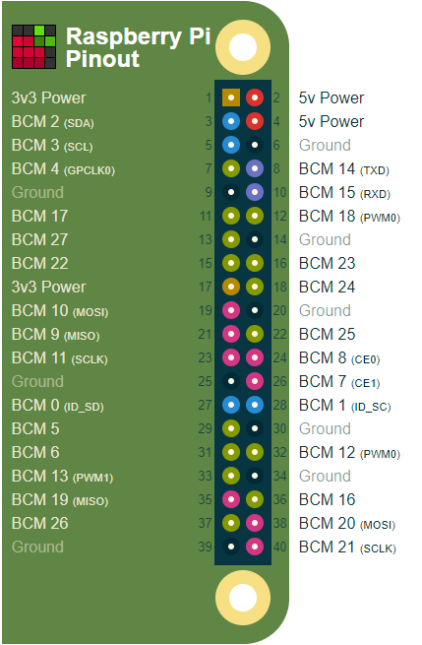

Raspbian OS

Although the Raspberry Pi’s operating system is closer to the Mac than Windows, it’s the latter that the desktop most closely resembles It might seem a little alien at first glance, but using Raspbian is hardly any different to using Windows (barring Windows 8 of course). There’s a menu bar, a web browser, a file manager and no shortage of desktop shortcuts of pre-installed applications. Raspbian is an unofficial port of Debian Wheezy armhf with compilation settings adjusted to produce optimized "hard float" code that will run on the Raspberry Pi. This provides significantly faster performance for applications that make heavy use of floating point arithmetic operations. All other applications will also gain some performance through the use of advanced instructions of the ARMv6 CPU in Raspberry Pi.

Python

Python is an interpreted, object-oriented, high-level programming language with dynamic semantics. Its high-level built in data structures, combined with dynamic typing and dynamic binding, make it very attractive for Rapid Application Development, as well as for use as a scripting or glue language to connect existing components together. Python's simple, easy to learn syntax emphasizes readability and therefore reduces the cost of program maintenance. Python supports modules and packages, which encourages program modularity and code reuse. The Python interpreter and the extensive standard library are available in source or binary form without charge for all major platforms, and can be freely distributed.
Since there is no compilation step, the edit-test-debug cycle is incredibly fast. Debugging Python programs is easy, a bug or bad input will never cause a segmentation fault. Instead, when the interpreter discovers an error, it raises an exception. When the program doesn't catch the exception, the interpreter prints a stack trace. A source level debugger allows inspection of local and global variables, evaluation of arbitrary expressions, setting breakpoints, stepping through the code a line at a time, and so on. The debugger is written in Python itself, testifying to Python's introspective power. On the other hand, often the quickest way to debug a program is to add a few print statements to the source: the fast edit-test-debug cycle makes this simple approach very effective.
OpenCV

OpenCV (Open Source Computer Vision Library) is an open source computer vision and machine learning software library. OpenCV was built to provide a common infrastructure for computer vision applications and to accelerate the use of machine perception in the commercial products. Being a BSD-licensed product, OpenCV makes it easy for businesses to utilize and modify the code.
The library has more than 2500 optimized algorithms, which includes a comprehensive set of both classic and state-of-the-art computer vision and machine learning algorithms. These algorithms can be used to detect and recognize faces, identify objects, classify human actions in videos, track camera movements, track moving objects, extract 3D models of objects, produce 3D point clouds from stereo cameras, stitch images together to produce a high resolution image of an entire scene, find similar images from an image database, remove red eyes from images taken using flash, follow eye movements, recognize scenery and establish markers to overlay it with augmented reality, etc.
It has C++, Python, Java and MATLAB interfaces and supports Windows, Linux, Android and Mac OS. OpenCV leans mostly towards real-time vision applications and takes advantage of MMX and SSE instructions when available. There are over 500 algorithms and about 10 times as many functions that compose or support those algorithms. OpenCV is written natively in C++ and has a templated interface that works seamlessly with STL containers.

XML ( Extensible Markup Language)

Extensible Markup Language (XML) is used to describe data. The XML standard is a flexible way to create information formats and electronically share structured data via the public Internet, as well as via corporate networks.
XML code, a formal recommendation from the World Wide Web Consortium(W3C), is similar to Hypertext Markup Language (HTML). Both XML and HTML contain markup symbols to describe page or file contents. HTML code describes Web page content (mainly text and graphic images) only in terms of how it is to be displayed and interacted with.
XML data is known as self-describing or self-defining, meaning that the structure of the data is embedded with the data, thus when the data arrives there is no need to pre-build the structure to store the data; it is dynamically understood within the XML. The XML format can be used by any individual or group of individuals or companies that want to share information in a consistent way. XML is actually a simpler and easier-to-use subset of the Standard Generalized Markup Language (SGML), which is the standard to create a document structure.
The basic building block of an XML document is an element, defined by tags. An element has a beginning and an ending tag. All elements in an XML document are contained in an outermost element known as the root element. XML can also support nested elements, or elements within elements. This ability allows XML to support hierarchical structures. Element names describe the content of the element, and the structure describes the relationship between the elements.

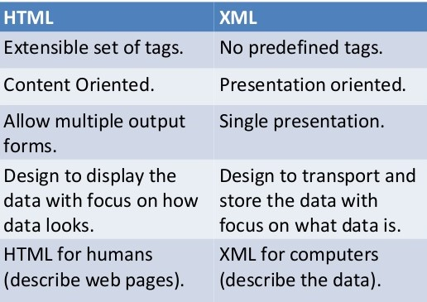

Haar Cascade Classifier

Object Detection using Haar feature-based cascade classifiers is an effective object detection method proposed by Paul Viola and Michael Jones in their paper, "Rapid Object Detection using a Boosted Cascade of Simple Features" in 2001. It is a machine learning based approach where a cascade function is trained from a lot of positive and negative images. It is then used to detect objects in other images.
Car Tracking Algorithm
For every frame:
- Detect potential regions of interest.
- Filter detected regions based on vertical, horizontal similarity.
- If its a new region, add to the collection.
- Clear collection every 30 frames.

Removing False Positives
The mean square error function is used to remove false positives. We compare vertical and horizontal sides of the images. If the difference is to large or to small it cannot be a car.

ROI Detection
A car may not be detected in every frame. If a new car is detected, its added to the collection.
We keep this collection for 30 frames, then clear it.

The cascades are not rotation invariant, scale and translation invariant. In addition, Detecting vehicles with haar cascades may work reasonably well, but there is gain with other algorithms (salient points).

Syntax for using Haar Cascade Classifier : cascade = cv2.CascadeClassifier('cars.xml')

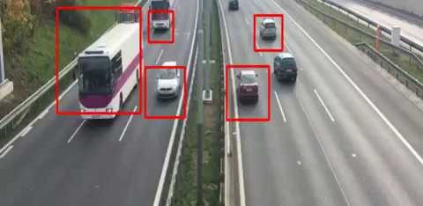

CHAPTER 4

NUMBER PLATE RECOGNITION

4.1 GRAYSCALE IMAGE :

Grayscale is a range of shades of gray without apparent color. The darkest possible shade is black, which is the total absence of transmitted or reflected light. The lightest possible shade is white, the total transmission or reflection of light at all visible wavelength’s. Intermediate shades of gray are represented by equal brightness levels of the three primary colors (red, green and blue) for transmitted light, or equal amounts of the three primary pigments (cyan, magenta and yellow) for reflected light.
In the case of transmitted light (for example, the image on a computer display), the brightness levels of the red (R), green (G) and blue (B) components are each represented as a number from decimal 0 to 255, or binary 00000000 to 11111111. For every pixel in a red-green-blue ( RGB ) grayscale image, R = G = B. The lightness of the gray is directly proportional to the number representing the brightness levels of the primary colors. Black is represented by R = G = B = 0 or R = G = B = 00000000, and white is represented by R = G = B = 255 or R = G = B = 11111111. Because there are 8 bit s in the binary representation of the gray level, this imaging method is called 8-bit grayscale.
In the case of reflected light (for example, in a printed image), the levels of cyan (C), magenta (M), and yellow (Y) for each pixel are represented as a percentage from 0 to 100. For each pixel in a cyan-magenta-yellow (CMY) grayscale image, all three primary pigments are present in equal amounts. That is, C = M = Y. The lightness of the gray is inversely proportional to the number representing the amounts of each pigment. White is thus represented by C = M = Y = 0, and black is represented by C = M = Y = 100.
In some systems that use the RGB color model, there are 2 16 , or 65,636, possible levels for each primary color. When R = G = B in this system, the image is known as 16-bit grayscale because the decimal number 65,536 is equivalent to the 16-digit binary number 1111111111111111. As with 8-bit grayscale, the lightness of the gray is directly proportional to the number representing the brightness levels of the primary colors. As one might expect, a 16-bit digital grayscale image consumes far more memory or storage than the same image, with the same physical dimensions, rendered in 8-bit digital grayscale.
In analog practice, grayscale imaging is sometimes called "black and white," but technically this is a misnomer. In true black and white, also known as halftone, the only possible shades are pure black and pure white. The illusion of gray shading in a halftone image is obtained by rendering the image as a grid of black dots on a white background (or vice-versa), with the sizes of the individual dots determining the apparent lightness of the gray in their vicinity. The halftone technique is commonly used for printing photographs in newspapers.
In some cases, rather than using the RGB or CMY color models to define grayscale, three other parameters are defined. These are hue, saturation and brightness . In a grayscale image, the hue (apparent color shade) and saturation (apparent color intensity) of each pixel is equal to 0. The lightness (apparent brightness) is the only parameter of a pixel that can vary. Lightness can range from a minimum of 0 (black) to 100 (white).

4.2 IMAGE SEGMENTATION :
In computer vision, image segmentation is the process of partitioning a digital image into multiple segments (sets of pixels, also known as super-pixels). The goal of segmentation is to simplify and/or change the representation of an image into something that is more meaningful and easier to analyze. Image segmentation is typically used to locate objects and boundaries (lines, curves, etc.) in images. More precisely, image segmentation is the process of assigning a label to every pixel in an image such that pixels with the same label share certain characteristics.
The result of image segmentation is a set of segments that collectively cover the entire image, or a set of contours extracted from the image (see edge detection). Each of the pixels in a region are similar with respect to some characteristic or computed property, such as color, intensity, or texture. Adjacent regions are significantly different with respect to the same characteristics. When applied to a stack of images, typical in medical imaging, the resulting contours after image segmentation can be used to create 3D reconstructions with the help of interpolation algorithms like Marching cubes.
Some of the practical applications of image segmentation are:
Object Detection:
- Pedestrian detection
- Face detection
- Brake light detection
- Locate objects in satellite images (roads, forests, crops, etc.)
Recognition Tasks:
- Face recognition
- Fingerprint recognition
- Iris recognition
Traffic control systems
Video surveillance
Several general-purpose algorithms and techniques have been developed for image segmentation. To be useful, these techniques must typically be combined with a domain's specific knowledge in order to effectively solve the domain's segmentation problems.

4.3 THRESHOLDING

What is Thresholding?

The simplest segmentation method

Application example: Separate out regions of an image corresponding to objects which we want to analyze. This separation is based on the variation of intensity between the object pixels and the background pixels.

To differentiate the pixels we are interested in from the rest (which will eventually be rejected), we perform a comparison of each pixel intensity value with respect to a threshold (determined according to the problem to solve).

Once we have separated properly the important pixels, we can set them with a determined value to identify them (i.e. we can assign them a value of (black), (white) or any value that suits your needs).
- 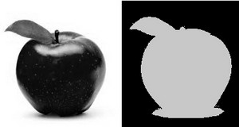

Types of Thresholding

OpenCV offers the function threshold to perform thresholding operations.

We can effectuate types of Thresholding operations with this function. We will explain them in the following subsections.

To illustrate how these thresholding processes work, let’s consider that we have a source image with pixels with intensity values . The plot below depicts this. The horizontal blue line represents the threshold (fixed).
- 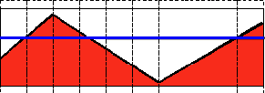

Threshold Binary

This thresholding operation can be expressed as:

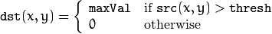

So, if the intensity of the pixel is higher than , then the new pixel intensity is set to a . Otherwise, the pixels are set to .
- 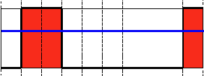

Threshold Binary, Inverted

This thresholding operation can be expressed as:

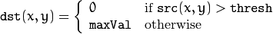

If the intensity of the pixel is higher than , then the new pixel intensity is set to a . Otherwise, it is set to .
- 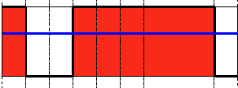

Truncate

This thresholding operation can be expressed as:

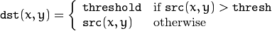

The maximum intensity value for the pixels is , if is greater, then its value is truncated. See figure below:
- 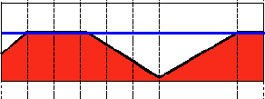

Threshold to Zero

This operation can be expressed as:

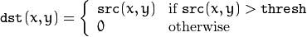

If is lower than , the new pixel value will be set to .
- 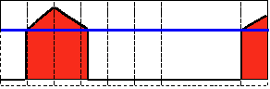

Threshold to Zero, Inverted

This operation can be expressed as:

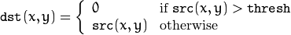

If is greater than , the new pixel value will be set to .
- 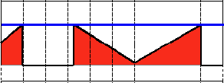

What is Thresholding?

The simplest segmentation method

Application example: Separate out regions of an image corresponding to objects which we want to analyze. This separation is based on the variation of intensity between the object pixels and the background pixels.

To differentiate the pixels we are interested in from the rest (which will eventually be rejected), we perform a comparison of each pixel intensity value with respect to a threshold (determined according to the problem to solve).

Once we have separated properly the important pixels, we can set them with a determined value to identify them (i.e. we can assign them a value of (black), (white) or any value that suits your needs).

Types of Thresholding

OpenCV offers the function threshold to perform thresholding operations.

We can effectuate types of Thresholding operations with this function. We will explain them in the following subsections.

To illustrate how these thresholding processes work, let’s consider that we have a source image with pixels with intensity values . The plot below depicts this. The horizontal blue line represents the threshold (fixed).

Threshold Binary

This thresholding operation can be expressed as:

So, if the intensity of the pixel is higher than , then the new pixel intensity is set to a . Otherwise, the pixels are set to .

Threshold Binary, Inverted

This thresholding operation can be expressed as:

If the intensity of the pixel is higher than , then the new pixel intensity is set to a . Otherwise, it is set to .

Truncate

This thresholding operation can be expressed as:

The maximum intensity value for the pixels is , if is greater, then its value is truncated. See figure below:

Threshold to Zero

This operation can be expressed as:

If is lower than , the new pixel value will be set to .

Threshold to Zero, Inverted

This operation can be expressed as:

If is greater than , the new pixel value will be set to .

As mentioned in the Chapter 1 subsection 1.3.2 Methodology for Improved Canny detection the design process is divided into 5 steps. They are
- Apply Gaussian filter to smooth the image in order to remove the noise
- Find the intensity gradients of the image
- Apply non-maximum suppression on 8th neighbourhood to get rid of spurious response to edge detection.
- Apply Adaptive threshold to determine potential edges.
- Track edge by hysteresis: Finalize the detection of edges by suppressing all the other edges that are weak and not connected to strong edges.
4.1.1 Gaussian filter and Gradient Computation Algorithm:
Algorithm for designing Gaussian filter and computing Gradient is as follows
- Create an even-length 1-D separable Derivative of Gaussian filter.
- Determine filter length.
- Create 1-D Gaussian Kernel.
- Normalize to ensure kernel sums to one.

- Create 1-D Derivative of Gaussian Kernel.
- Normalize to ensure kernel sums to zero.
- Compute smoothed numerical gradient of image I along x (horizontal) direction . G_{x} corresponds to dG/dx, where G is the Gaussian Smoothed version of image I.
- Compute smoothed numerical gradient of image I along y (vertical) direction . G_{y} corresponds to dG/dy, where G is the Gaussian Smoothed version of image I.
- Calculate Magnitude of Gradient.
- Compute directions of the gradient obtained for the above steps.
4.1.2 Non maxima suppression Algorithm:
Algorithm for Non maxima suppression
- Discretize the total available gradient directions into 4 directions , namely (0-45),(45-90),(90-135),(135-180).
- Set the boundary pixels to zero.
- For each kind of direction, interpolate and see if the edge strength of the current pixel is largest if largest preserve the value . 8th neighborhood should be taken into consideration while checking the value.
- If not, suppress (i.e. remove) the value.

4.1.3 Adaptive Thresholding:
Adaptive thresholding is done by using mean of the normalized gradient values present in the neighborhood of the corresponding pixel.
Adaptive thresholding equation:
lowT = low * mean(sNorm(:));
High threshold value can be obtained by using the equation:
highT = high * lowT;
4.1.4Hysteresis Algorithm:
- Along the neighbourhood direction for pixel under consideration, add 0.4 to all the pixels(remember pixels are normalised )
- Check in the neighbourhood whether the number of pixels having value 1 is changed.
- If changed check the individual pixels, If the value of the pixel is greater than or equal to 1 mark the pixel and reset the corresponding value to 1.If less than 1 discard the pixel value and reset it to 0.
- Repeat the process from step 1 as long as the number of pixel values having 1 is changed.
- If there is no change in the number of pixels having then end the process.
Thus all the pixels having value 1 are considered as true edges and remaining are discarded as noise.

4.2 Flow charts:
4.2.1 Flow chart for Gaussian filter and gradient Computation:
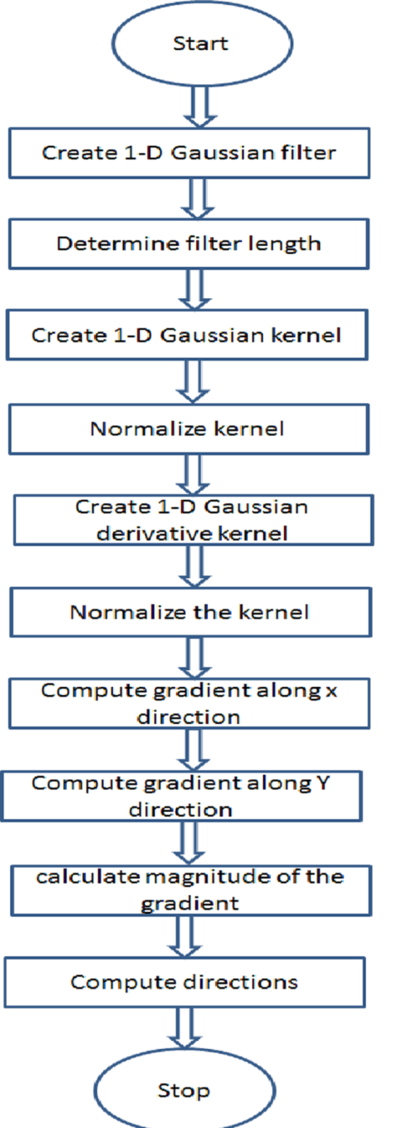
Fig 4.1 Flowchart for Gaussian filter and gradient Computation.
4.2.2 Flow chart for Non maxima suppression:
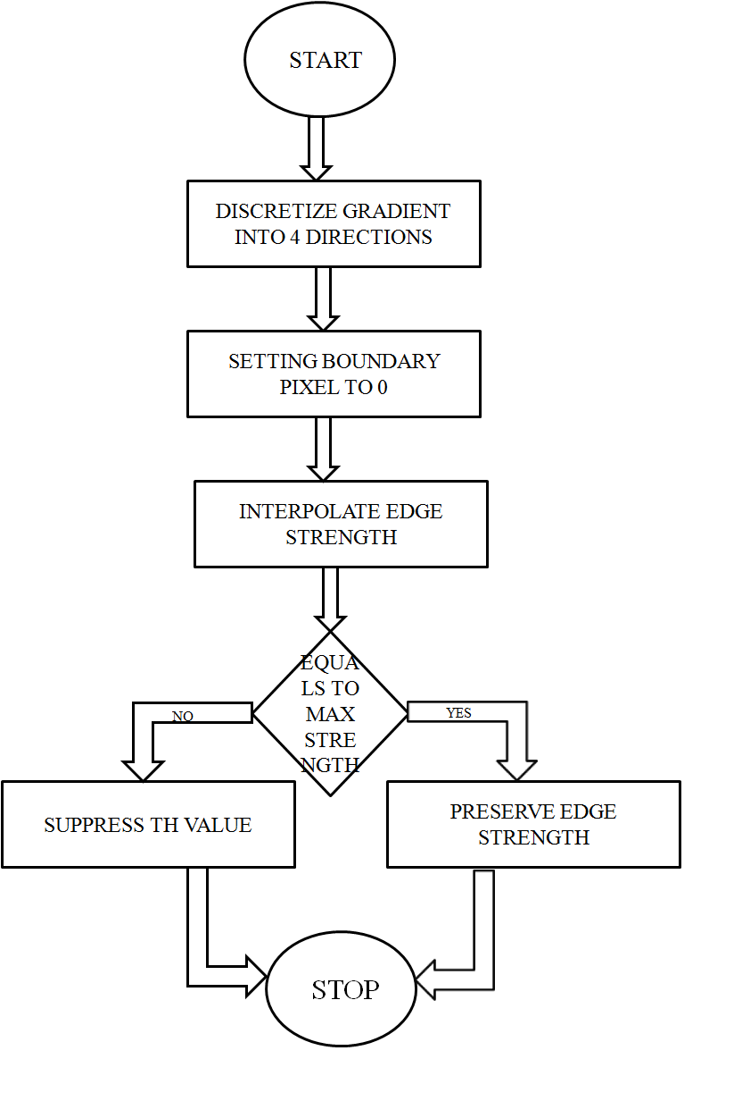
Fig 4.2 Flowchart for Non maxima suppression.

4.2.3 Flowchart for Hysteresis:

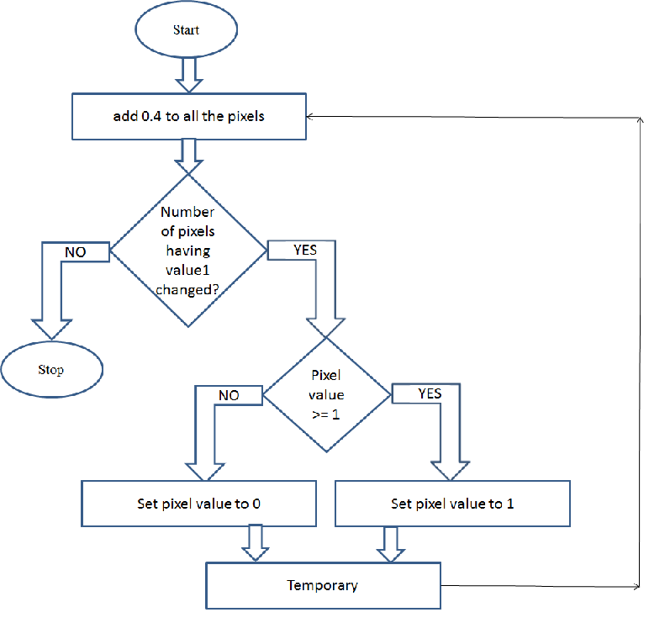
Fig 4.3 Flowchart for Hysteresis.

4.3 Improved Canny Edge Detection code :
Improved Canny Edge Detection code is divided into two ".m"(matlab) files.
- First file - canny.m
- Second file - test.m
First file(canny) works as function itself it can be used as a function with any other matlab works. As first file is a function it cannot be used directly. It should be called as a function from another file.
Second file uses both edge function (inbuilt) and first file which is also a function. We can directly run the second file. On running second file it will produces the output. Output consist of original image, edges formed by using inbuilt edge function and edges formed by using improved canny output.
4.3.1 canny.m :
% declaration and definition of canny function
% license @MGIT ECE Department

function[IFinal , thresh]=canny(img,low,high,sigma)

% return types
% IFinal the final black and white edge image
%thresh=[low_thresh high_thresh] actual low and high thrsholds used

%input ty3pes
%img given image color or black and white
%low : lower Threshold (is seted adaptively)
%high : higher Threshold (is seted adaptively)
%sigma : vlue of sigma
...................

%default values
%sigma :1 , low:0.5 , high:2.5

% input parsing
% nargin : Inside the body of a user-defined function, nargin returns
%the number of input arguments that were used to call the
%function.

if (nargin < 1)
error(' Need a NxNx3 or NxN image matrix');
elseif (nargin ==1)
low = 0.5; high = 2.5; sigma = 1;
elseif (nargin == 2)
high = 2.5; sigma = 1;
elseif (nargin == 3)
sigma = 1;
end

i =img ;

% converting RGB to Gray image
% ndimns: returns dimensions in the array .

origimage = img;

if (ndims(img)==3)
img =double(rgb2gray(img));
end

% smoothing
% dg gaussian derivative , g gaussian expression
% ceil rounds towards positive infinity
% floor rounds towards -ve infinity

x = floor(-3*sigma):ceil(3*sigma);
G = exp(-0.5*x.^2/sigma^2); % gaussian expression
G = G/sum(G); % normalization
dG = -x.*G/sigma^2;

[d , fillen] = size(dG);
offset = (fillen-1)/2;

sy = conv2(img, dG ,'same');
sx = conv2(img, dG','same');

[m, n]=size(img);

% crop off the boundary parts...the places where the convolution was partial
sx = sx(offset+1:m-offset, offset+1:n-offset);
sy = sy(offset+1:m-offset, offset+1:n-offset);

% norm of gradient
sNorm = sqrt( sx.^2 + sy.^2 );

% direction of gradient
sAngle = atan2( sy, sx) * (180.0/pi);

% handle divide by zero....
sx(sx==0) = 1e-10;
sSlope = abs(sy ./ sx);

sAorig = sAngle;

%for us, x and x-pi are the same....
y = sAngle < 0;
sAngle = sAngle + 180*y;

% bin the angles into 4 principal directions
% 0-45 45-90 90-135 135-180

binDist = [-inf 45 90 135 inf];

[dummy, b] = histc(sAngle,binDist);

sDiscreteAngles = b;
[m,n] = size(sDiscreteAngles);

% each pixel is set to either 1,2,3 or 4
% set the boundary pixels to 0, so we don't count them in analysis...
sDiscreteAngles(1,:) = 0;
sDiscreteAngles(end,:)=0;
sDiscreteAngles(:,1) = 0;
sDiscreteAngles(:,end) = 0;

sEdgepoints = zeros(m,n);

sFinal = sEdgepoints;

lowT = low * mean(sNorm(:));
highT = high * lowT;

thresh = [ lowT highT];

% NON-MAXIMAL SUPPRESSION

% for each kind of direction, interpolate.... and see if the current point

% is the local maximum in that direction

%in the following comments, assume that we are currently at (0,0) and
%we have to interpolate from the 8 surrounding pixels, also, we are
%using MATLAB's single index feature...

%gradient direction: 0-45 i.e. gradDir =1
gradDir = 1;
indxs = find(sDiscreteAngles == gradDir);
slp = sSlope(indxs);

% interpolate between (1,1) and (1,0)

% gDiff1 = Gy/Gx*(magtd(0,0) - magtd(1,1)) + (1- Gy/Gx)*(magtd(0,0)-magtd(1,0))

gDiff1 = slp.*(sNorm(indxs)-sNorm(indxs+m+1)) + (1-slp).*(sNorm(indxs)-sNorm(indxs+1));

% interpolate between (-1,-1) and (-1,0)

% gDiff2 = Gy/Gx*(magtd(0,0) - magtd(-1,-1)) + (1- Gy/Gx)*(magtd(0,0)-magtd(-1,0))

gDiff2= slp.*(sNorm(indxs)-sNorm(indxs-m-1)) + (1-slp).*(sNorm(indxs)-sNorm(indxs-1));

okIndxs = indxs( gDiff1 >=0 & gDiff2 >= 0);
sEdgepoints(okIndxs) = 1;

%gradient direction: 45-90 i.e. gradDir =2
gradDir = 2;
indxs = find(sDiscreteAngles == gradDir);
invSlp = 1 ./ sSlope(indxs);

% interpolate between (1,1) and (0,1)
% gDiff1 = (Gx/Gy)*(magtd(0,0) - magtd(1,1)) + (1- Gx/Gy)*(magtd(0,0)-magtd(0,1))

gDiff1 = invSlp.*(sNorm(indxs)-sNorm(indxs+m+1)) + (1-invSlp).*(sNorm(indxs)-sNorm(indxs+m));

% interpolate between (-1,-1) and (0,-1)
% gDiff2 = (Gx/Gy)*(magtd(0,0) - magtd(-1,-1)) + (1- Gx/Gy)*(magtd(0,0)-magtd(0,-1))

gDiff2 = invSlp.*(sNorm(indxs)-sNorm(indxs-m-1)) + (1-invSlp).*(sNorm(indxs)-sNorm(indxs-m));

okIndxs = indxs( gDiff1 >=0 & gDiff2 >= 0);
sEdgepoints(okIndxs) = 1;

%gradient direction: 90-135 i.e. gradDir =3
gradDir = 3;

indxs = find(sDiscreteAngles == gradDir);
invSlp = 1 ./ sSlope(indxs);

% interpolate between (-1,1) and (0,1)

% gDiff1 = (Gx/Gy)*(magtd(0,0) - magtd(-1,1)) + (1- Gx/Gy)*(magtd(0,0)-magtd(0,1))

gDiff1=invSlp.*(sNorm(indxs)-sNorm(indxs+m-1))+(1-invSlp).*(sNorm(indxs)-sNorm(indxs+m));

% interpolate between (1,-1) and (0,-1)

% gDiff2 = (Gx/Gy)*(magtd(0,0) - magtd(1,-1)) + (1- Gx/Gy)*(magtd(0,0)-magtd(0,-1))

gDiff2=invSlp.*(sNorm(indxs)-sNorm(indxs-m+1))+(1-invSlp).*(sNorm(indxs)-sNorm(indxs-m));

okIndxs = indxs( gDiff1 >=0 & gDiff2 >= 0);
sEdgepoints(okIndxs) = 1;

%gradient direction: 135-180 i.e. gradDir =4

gradDir = 4;
indxs = find(sDiscreteAngles == gradDir);

slp = sSlope(indxs);

% interpolate between (-1,1) and (-1,0)

% gDiff1 = Gy/Gx*(magtd(0,0) - magtd(-1,1)) + (1- Gy/Gx)*(magtd(0,0)-magtd(-1,0))

gDiff1=slp.*(sNorm(indxs)-sNorm(indxs+m-1))+(1-slp).*(sNorm(indxs)-sNorm(indxs-1));

% interpolate between (1,-1) and (1,0)

% gDiff2 = Gy/Gx*(magtd(0,0)-magtd(1,-1)) + (1- Gy/Gx)*(magtd(0,0)-magtd(1,0))

gDiff2=slp.*(sNorm(indxs)-sNorm(indxs-m+1)+(1-slp).*(sNorm(indxs)-sNorm(indxs+1));

okIndxs = indxs( gDiff1 >=0 & gDiff2 >= 0);

sEdgepoints(okIndxs) = 1;

%HYSTERESIS PART...

sEdgepoints = sEdgepoints*0.6;

x = find(sEdgepoints > 0 & sNorm < lowT);

sEdgepoints(x)=0;

x = find(sEdgepoints > 0 & sNorm >= highT);

sEdgepoints(x)=1;

%sFinal(sEdgepoints>0)=1;

%at this point, if
% sNorm(pixel) > lowT then sEdgepoints(pixel)=0
% highT > sNorm(pixel) > lowT then sEdgepoints(pixel)=0.6
% sNorm(pixel) > highT then sEdgepoints(pixel)=1

% the idea is this: along the neighbouring pixels in that direction
% add 0.4...so all points that were 0.6 will become 1.0
% see if the number of 1's has changed...
% keep doing while number of 1's doesn't change

% empty array
oldx = [ ];

x = find(sEdgepoints==1);

while (size(oldx,1) ~= size(x,1))

oldx = x;

v = [x+m+1, x+m, x+m-1, x-1, x-m-1, x-m, x-m+1, x+1];

sEdgepoints(v) = 0.4 + sEdgepoints(v);

y = sEdgepoints==0.4;

sEdgepoints(y) = 0;

y = sEdgepoints>=1;

sEdgepoints(y)=1;

x = find(sEdgepoints==1);
end

x = find(sEdgepoints==1);

sFinal(x)=1;

%figure(1);

%imagesc(sFinal); colormap(gray); axis image;

% return value for the canny function

imshow(sFinal);

4.3.2 test.m
clc;
close all;
clear all;

% reading the image

i =imread('mgit.jpg');

%converting pixel values to double

I=im2double(i);

% converting color images to gray

p=double(rgb2gray(I));

%new figure window

figure(1);

imshow(i);

% new figure window 2

figure(2);

imshow(edge(p,'canny'));

%new figure window 3

figure(3);
cannye(I);

4.4 Conclusion:

In Chapter 3, we discussed the limitations that occur with the use of edge() function in this chapter we show some possible means to overcome them. In this chapter we discussed about the improvements done for canny algorithm .
To eliminate the problem arisen due to the use of 2*2 window during gradient magnitude we considered the 8th neighbourhood during Non maxima suppression.
Moreover we use Adaptive thresholding opposed to normal thresholding. Thereby we can obtain the better edges while detection.
In the next chapter we compare our newly designed canny edge detection method against inbuilt edge function.

Chapter 5
RESULTS AND CONCLUSIONS
We will start this chapter by comparing Matlab inbuilt edge function and our function then we move on to compare the outputs of both canny edge detection methods and finally we conclude with the scope for future work.
5.1 Comparisons :
Table 5.1 Comparison of steps involved in design process
Steps | Inbuilt function | Improved canny
Gaussian Filtering | 1-Dimensional Gaussian filter. | 1-Dimensional Gaussian filter.
Gradient computation | 1st derivative of 1-Dimensional Gaussian filter. | 1st derivative of 1-Dimensional Gaussian filter.
Non maxima suppression | Discretization of pixels based on magnitude in the given direction is done by taking 2*2 neighbourhood into consideration. | Discretization of pixels based on magnitude in the given direction is done by taking 8th neighbourhood into consideration..
Thresholding | Normal dual thresholding done by selecting uniform threshold T_{low ,}T_{high} for the complete image. | Adaptive thresholding is done by selecting different threshold values in different parts of the image based on magnitude gradient.
Hysteresis | Weak edges that are connected to strong edges are considered as strong edges and remaining edges are discarded (no cross checking is provided) | True edges are discovered by continuously running algorithm provided in chapter 3.Automatic cross checking is provided by the algorithm.

Table 5.2 Parameter comparisions:
Parameters | Inbuilt function | Improved Canny
T_{low} to T_{high} ratio | 0.4 | 0.4
Sigma | 1 | 2.0
Supported image types | Grey, Black and White (jpg , png) | Colour, Grey, Black and White (jpg , png)
Method Invocation Syntax | - edge(image,'canny');  - edge(image,'canny',threshold,sigma); | - canny(image);  - canny(image, low);  - canny(image, low, high);  - canny(image, low, high, sigma);

5.2 Output comparisons:
5.2.1 visual comparison:
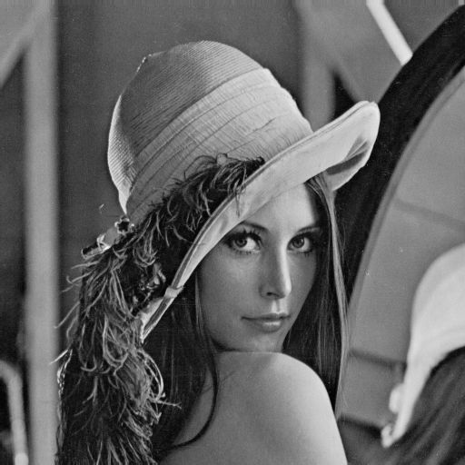
Fig 5.1 Lena original image

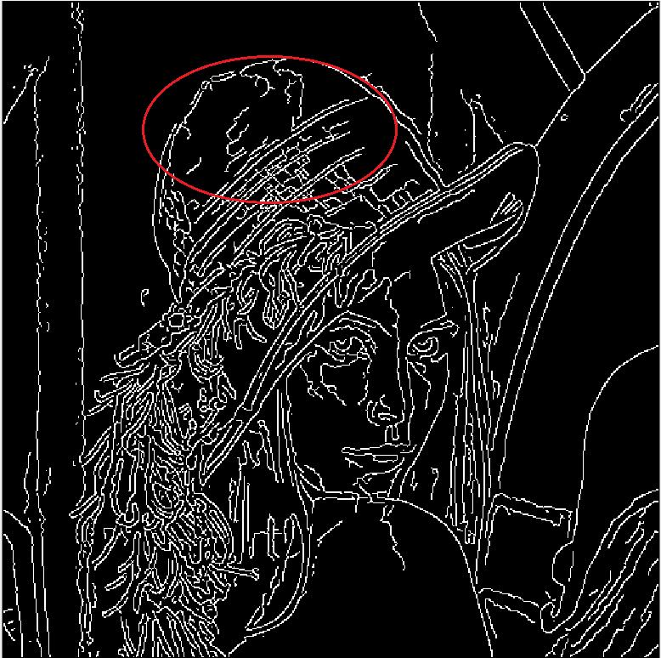
Fig 5.2 Lena output image by edge()

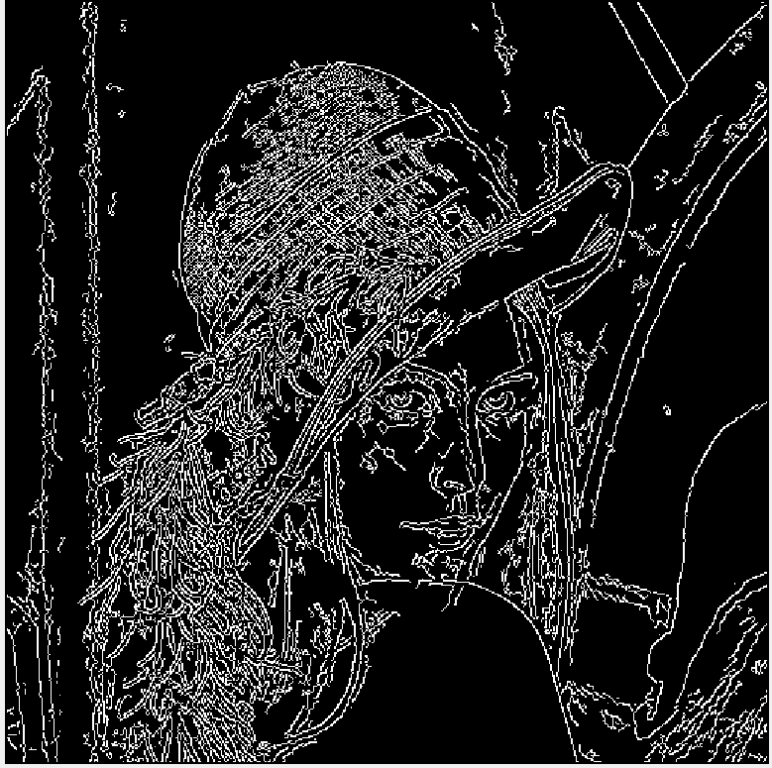
Fig 5.3 Lena output image using improved canny

Fig 5.4 CBIT LOGO original image.


Fig 5.5 CBIT LOGO output image by inbuilt function


Fig 5.6 CBIT LOGO output image by improved canny

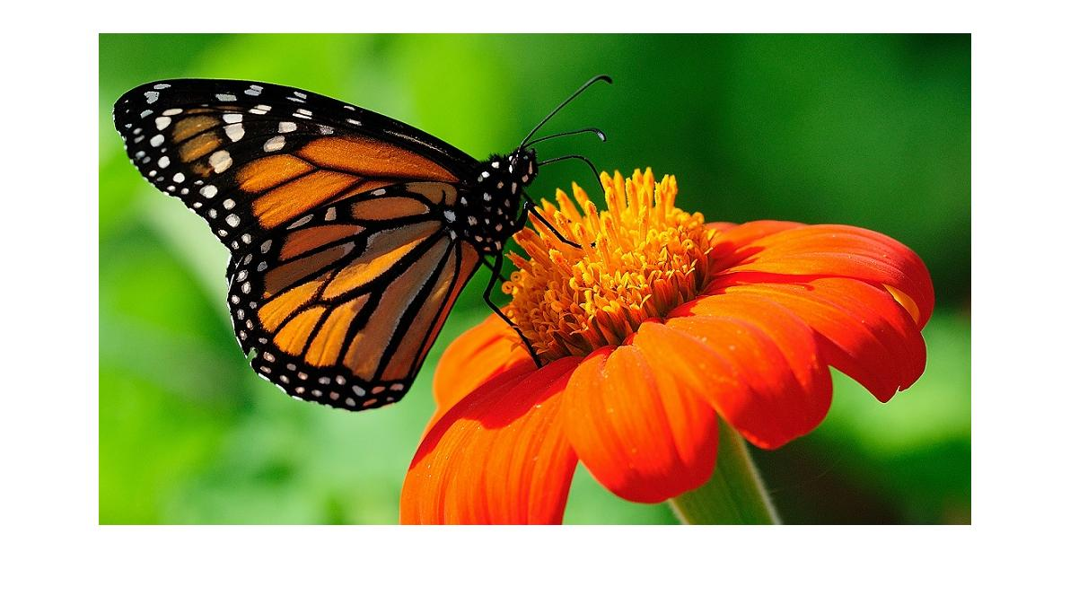
Fig 5.7 Butterfly original image.

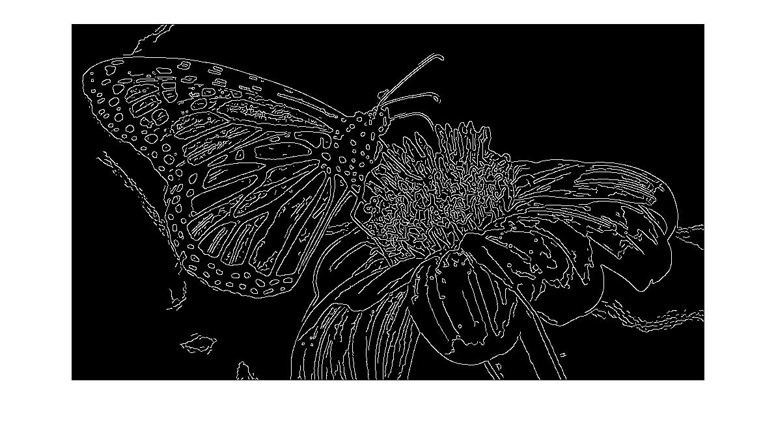
Fig 5.8 Butterfly output image by inbuilt function

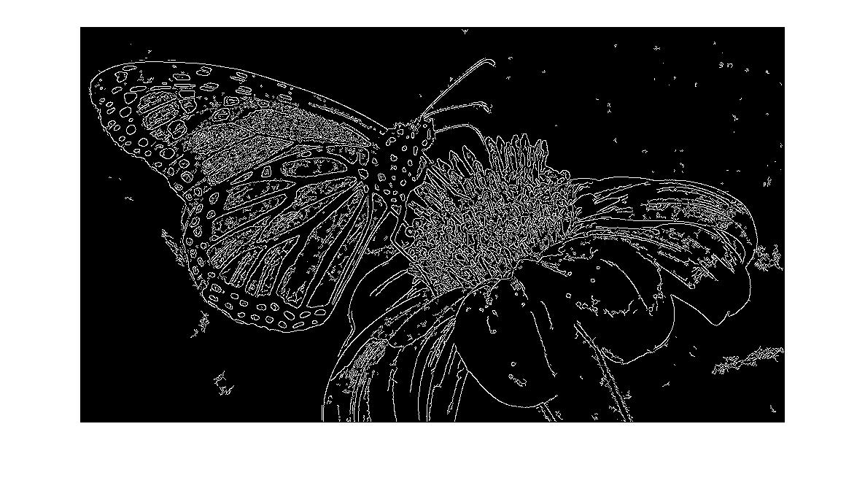
Fig 5.9 Butterfly output image by improved canny

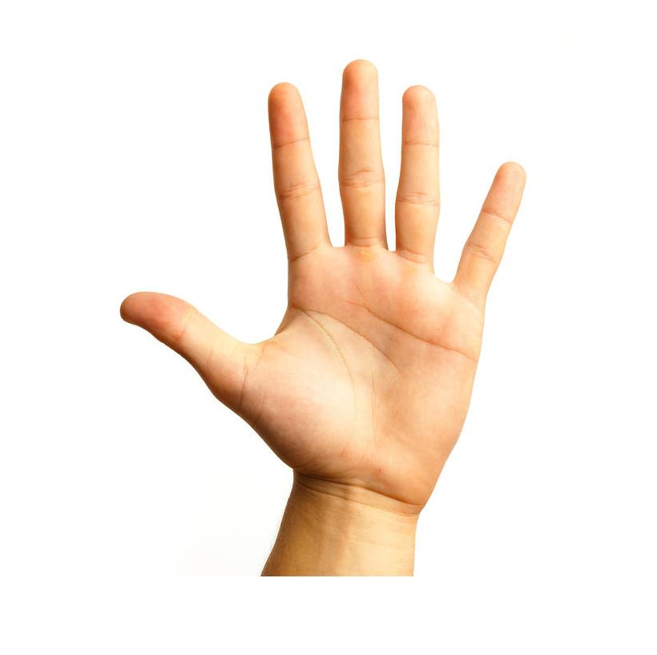

Fig 5.10 Hand original image

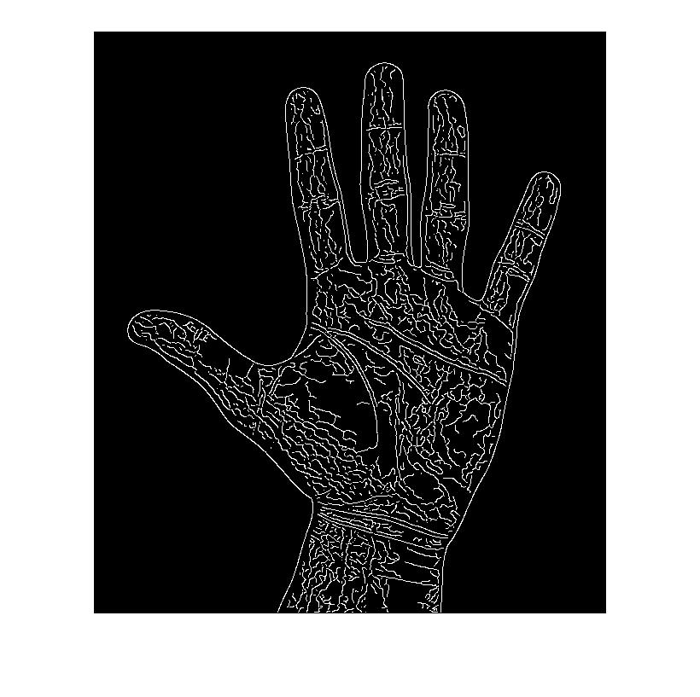
Fig 5.11 Hand output by inbuilt function

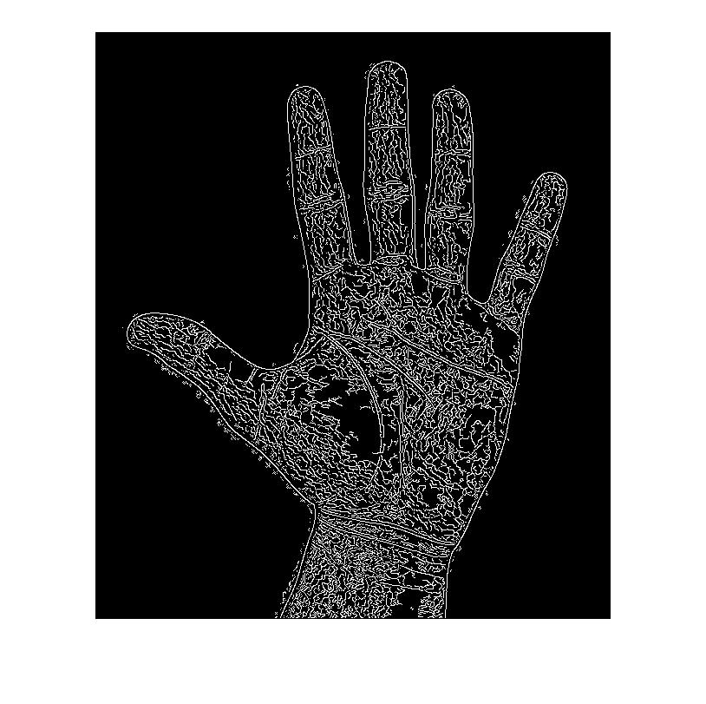
Fig 5.12 Hand output by improved canny

5.2.2 Profiler:
Profiler for inbuilt edge function is:
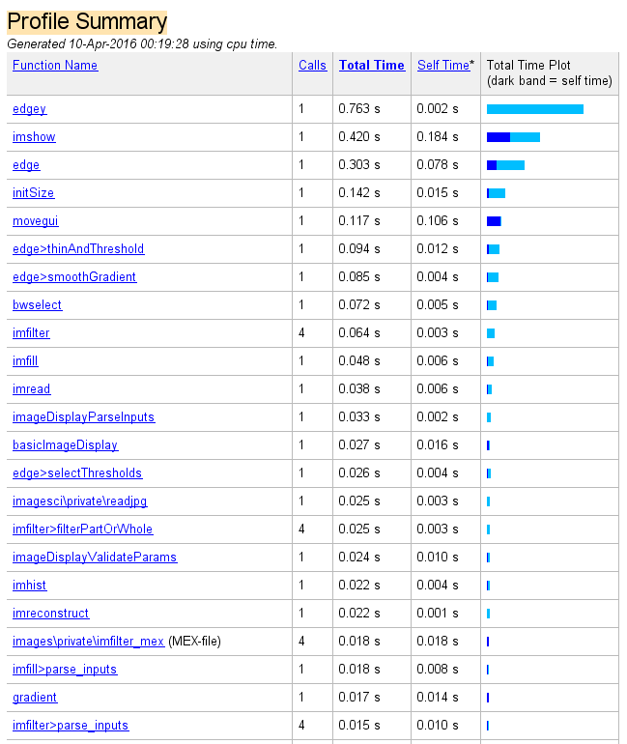
Fig 5.13 Profiler for inbuilt function.

The above profiler is for hand image. The time taken by inbuilt function to run hand image is 0.7 seconds(worst case is 1 sec and best case is 0.16 sec.).
Profiler for improved canny function is:
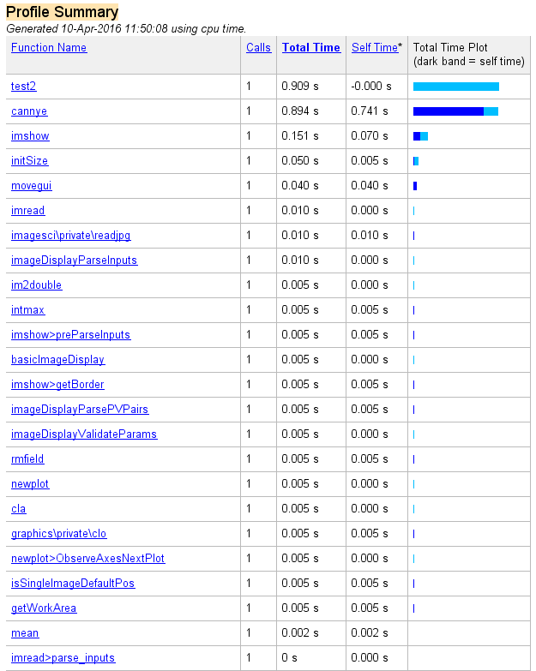

Fig 5.14 Profiler for improved canny function.

The above profiler is for hand image. The time taken by improved canny function to run hand image is 3.193 seconds(worst case is 3.193 sec and best case is 1.5 sec.).
The profiler time is dependent on CPU clock speed and RAM size. It may vary for different computing machines.

5.2.3 Time comparison:

Table 5.3
Image | Inbuilt in seconds | Improved in seconds
Lena | 0.9 | 1.2
Butterfly | 1.4 | 1.7
CBIT logo | 0.7 | 1
Hand | 1.3 | 2.1

5.3 PSNR and MSE comparisions:
The PSNR block computes the peak signal-to-noise ratio, in decibels, between two images. This ratio is often used as a quality measurement between the original and a compressed image. The higher the PSNR, the better the quality of the compressed, or reconstructed image.
psn = psnr(I2,Ib);

The Mean Square Error (MSE) and the Peak Signal to Noise Ratio (PSNR) are the two error metrics used to compare image compression quality. The MSE represents the cumulative squared error between the compressed and the original image, whereas PSNR represents a measure of the peak error. The lower the value of MSE, the lower the error. To compute the PSNR, the block first calculates the mean-squared error using the following equation:
MSE= M,N [I₁(m,n)−I₂(m,n)]2/M∗N
In the above equation, M and N are the number of rows and columns in the input images, respectively.
err = immse(I2,Ib)
Then the block computes the PSNR using the following equation:
PSNR=10log₁₀ (R²/ MSE ).

COMPARISON OF PSNR VALUES:
Table 5.4
Figure name | Inbuilt function | Improved canny function
Lena | 6.54 | 7.38
Butterfly | 8.76 | 8.86
CBIT logo | 7.59 | 10.58
Hand | 3.04 | 3.16

A higher PSNR value generally indicates that reconstruction is of higher quality in image compression.

COMPARISON OF MSEVALUES:
Table 5.5
Figure name | Inbuilt function | Improved canny function
Lena | 0.2214 | 0.2497
Butterfly | 0.401 | 0.4135
CBIT logo | 0.4598 | 0.6272
Hand | 0.184 | 0.1914

The MSE should be less, when you are processing with image restoration reconstruction and compression. But in terms of image detection, the Mean Square Error could be higher to ensure if found more edge points on the image and also capable of detect weak edges.

5.4 Future Scope of work:
With the help of operating system we can cross run this function for Face detection in real time as employed by the Iphone X
Robotic vision, object tracking etc; have edge detection as a part of them.
This project can further be extended into QR scanner.

5.5 Conclusion:
Thus, by changing some design considerations an improved canny edge detection method can be developed.

